Declaration
-----------

I, Tevyn Bains (N1079255), hereby declare that:

* I have read the "Referencing, Plagiarism and Collusion" section of the assessment specification.

* I am aware of the University's rules on plagiarism and collusion, and I understand that, if I am found to have broken these rules, this will be treated as an Academic Irregularity and dealt with accordingly.

* I am the sole author of the submitted program code and associated report, apart from the code referenced below.

References
----------

I have adapted/reused the following pieces of code from the following sources:

https://getbootstrap.com/docs/5.0/forms/validation/
These are screenshots of the code I ued on the website, I used this and adapted it to make my own form
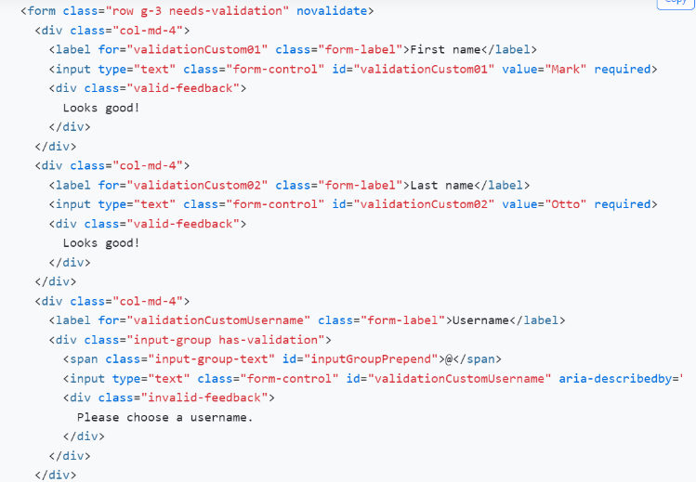
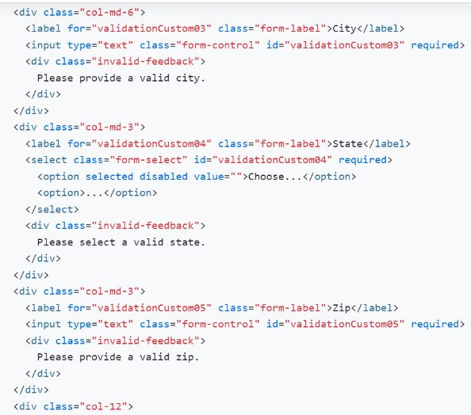

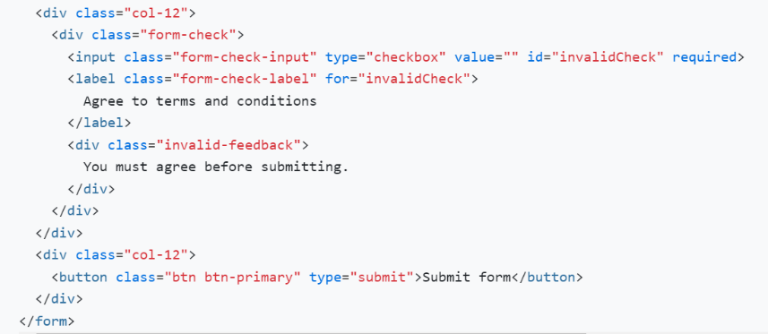

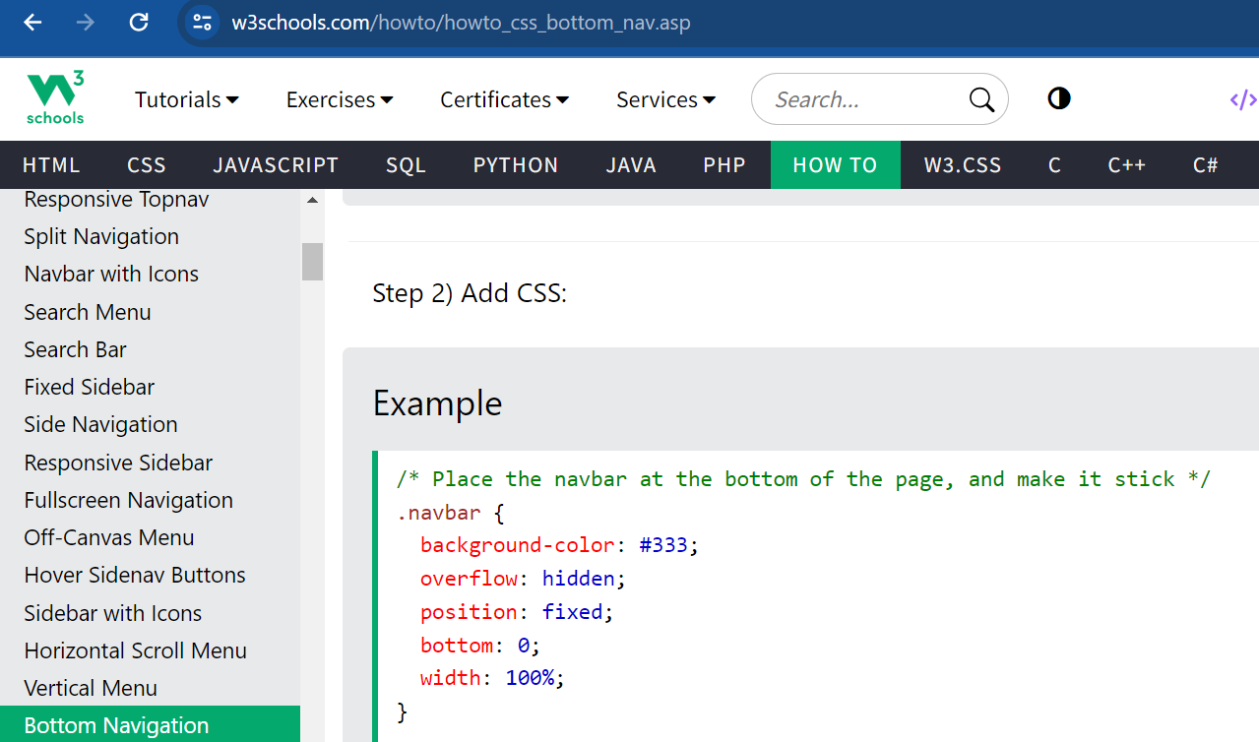
https://www.w3schools.com/howto/howto_css_bottom_nav.asp

https://getbootstrap.com/docs/4.0/layout/grid/

